CHAPTER 01
INTRODUCTION

  - PURPOSE

This project helps in maintaining the database of the class and examinations related information in any educational organization. We can easily access any class and examinations related information anytime and can be kept safely for long period of time without any damage and we also can contact with our course teachers.

  - SCOPE

Section Management System is a web-based application for students and teachers who want to get and retrieve class, examination, assignment etc whole information instantly via internet. The major benefit of this web portal is to store the section’s class schedule, examinations schedule, assignment, class-test, and quiz-test
Information at one place (like SERVER) and it can be accessed via online interaction. The Section Management System web portal is to replace the old and traditional file (paper work) storing process. Instead of tedious paper work, students will be able to get required information electronically, and the departments will be able to give the information’s with a much quicker turn around.

  - PROLBEM

Most of the students do not attend class regularly and they miss to know about their class-test or any quiz-test at most of the times. And often they do not check update of his class/examinations from their university’s website, they collects the information from their classmates. Here is a chance to get wrong information. So, the possible problems are given below:

- Students can’t attend the Class Test & Quiz Test.
- Students can’t take the preparation of Class Test & Quiz Test.
- Students can’t submit the Assignment in time.
- Students miss the class as they do not know the Class Schedule.
- PROPOSED SYSTEM
By developing the system we can attain the following system: Students miss the class as they do not know the Class Schedule.
• Easy to handle and feasible
• Fast and Convenient
  - OBJECTIVES

Section Management system is a management information system for education establishments to manage class and examinations related data. It provide capabilities for knowing class schedule, examinations schedule, assignment related information, to contact with course teachers etc. By developing this project, students can easily know about class and examinations information also can know the assignment submission date and its topic. We can summarize this in some point, they are:
- Students got Class Test & Quiz Test Schedule.
- Students can submit the Assignment in time.
- Students know the able to Class Schedule.

CHAPTER 02
INTRODUCTION

  - MODULES

- Home
- Resources
- EBooks
- Slide
- Notes
- Video tutorial
- Course Outlines
- Necessary Software
- Schedules
- Class schedule
- Exam schedule
- Contact
- Teacher contact
- Student contact
- Results
- First-spring 2016
- Second-summer 2016
- Third-fall 2016-17
- Fourth-spring 2017
- Fifth-summer 2017
- Sixth-fall 2017-18
- Sixth-fall 2017-18
- Running-Spring 2018
- About us

  - EXPLANATION OF MODULES

- RESOURCES
In our recourses we have included
- EBooks
- Slide
- Notes
- Video tutorial
- Course Outlines
- Necessary Software

- EBOOKS

In eBooks, user can find their needed book as PDF. Some people don’t want to buy books because they prefer to read PDF and our website is the best option for them. I would like to mention that our website is totally free of cost.

- SLIDE

All kinds of slides link will also available in our site. Some of our Teachers prefer to give lecture by using slide. Because in book everything is written in details, sometimes it is quite impossible to give lecture by books because our class time is too short to give lecture in details. Besides Students also prefer slide because slide have only the key points of any Topics. When the teacher highlights the key points and gives lecture, these Helps the students to understand the topic easily.

- NOTES
All kinds of class notes will be here as a PDF file. Anyone who Need any notes they can collect it from our site. The notes will be sorted according to the current semester. This site has a great effectiveness to all the students especially for the irregular students. Some of the student don’t attentive in the class, some of are regularly late and some are regularly absent in the class, for these reasons they couldn’t collect the daily class lectures. But some students are so attentive and active in the class and they write the entire class lecture even a single point and make notes. Then irregular student copy the notes as photocopy or take picture. We will collect all that notes and add to our website as a PDF file so that irregular student can get benefit.
- VIDEO TUTORIAL

All kinds of important video tutorials related to our courses will be uploaded here as a link. There are many benefits to use video tutorial in education, such as-
- Great for visuals learners
- independent learning-accessible anywhere any time
- easy to find
- short and to the point
- ability to skip unnecessary point
- can be paused and saved for later
- free and alternative to courses and books
But sometimes it creates problem to identify a tutorial because in YouTube there are many tutorials is uploaded for a specific topic so they become so confuse to identify that “Which will be suitable for them”? And it is also time consuming.
That’s why the video will be uploaded by measuring effectiveness and efficiency.

- COURSE OUTLINES
Course outline will also available in our website. It is a document that benefits student, works as a guide and provides an overall plan for their courses. It contains important information such as course description, course schedule, assessment tasks, assessment submission procedures, grades of assessment, exam date and your responsibilities as a student. University offers the course outline to the student during the first week of classes. But sometimes student lose it. That’s why we have decided to include this option in our website.

- NECESSARY SOFTWARE
As student of CSE field, student need to learn several programming languages. Each language has a specific software, such as-
- C/C++ (Code blocks).
- Java (NetBeans).
- Database (XAMP, SQL).

All kinds of necessary software will be available in our website. Student can easily find their necessary software from our site.
- SCHEDULE
In schedule we have included
- Class Schedule
- Exam Schedule

- CLASS SCHEDULE
The regular class schedule will be uploaded according to the current semester. Some student take retakes/improvement, so it will be also included in schedule. When the semester will pass, admin will change the schedule and will set the new one.

- EXAM SCHEDULE

Mid/Final term exam schedule will be uploaded here. If any changes is needed then admin will change these according to the changes.
- CONTACTS
In contacts we have included
- Teacher Contact
- Student Contact

- TEACHER CONTACT
Course teacher’s phone number and E-mail id will be added here.
- STUDENT CONTACT
All the student of our section’s phone number and E-mail id will be added here.

- RESULTS
From the 1st semester to last semester result will be uploaded here.

CHAPTER 03
SYSTEM DESIGN

  - DATABASE STRUCTURE MODELING

In the database structure modeling, firstly we look forward to data of our system. Then we divided our data in 3 categories. That are-
- Static Data
- Semi Static Data
- Dynamic Data

- Static Data
Static data is data that does not change after being recorded. It is a fixed data set. In our system we used Static Data in CR_PANEL table. Such as ID, USERNAME, PASSWORD, E-MAIL, MOBILE this does not change.

- Semi Static Data
Semi Static is data that sometimes change after being recorded. In our system we used Semi Static Data in Contacts table. Such as- ID, NAME, E-MAIL, MOBILE, INTAKE_SECTION, ROOM_NO, TYPE, SHORT_CODE, CR_ID which sometimes change.

- Dynamic Data
Dynamic data may change after it is recorded, and has to be continually updated. In our system we used Dynamic Data in Schedule table and Notice Board table. Such as- SERIAL_ID, DATE, TIME, C_CODE, C_TITLE, ROOM_NO, TYPE, CR_ID, SERIAL_NO, SUBMISSION_DATE, PUBLISH_DATE etc which are continually updated. But we see that same data are occurs twice. This is time consuming. For this reason we normalize our data. Then we are using this data in database modeling.

  - DATABASE DESIGN VIEW
Table 3.2.1: ADMIN / CR
Table 3.2.2: NOTICE BOARD
Field | Type | Null | Key | Description
SERIAL_NO | INT(20) | NOT NULL | PRIMARY KEY | SERIAL NUMBER
TITLE | varchar(50) | NO |  | TITLE
COURSE_CODE | varchar(50) | NO |  | COURSE CODE
TOPICS | varchar(50) | NO |  | TOPICS
PUBLISH_DATE | DATE | NO |  | PUBLISH DATE
TYPE | varchar(50) | NO |  | TYPE
SUBMISSION_DATE | varchar(50) | NO |  | SUBMISSION DATE
TIME | DATETIME | NO |  | TIME

Field | Type | Null | Key | Description
ID | INT(20) | NOT NULL | PRIMARY | ADMIN ID NUMBER
USERNAME | varchar(50) | NO |  | ADMIN USERNAME
PASSWORD | varchar(50) | NO |  | ADMIN PASSWORD
EMAIL | varchar(50) | NO |  | MAIL ADDRESS
MOBILE | INT(20) | NO |  | MOBILE NUMBER

Table 3.2.2: SCHEDULE
Field | Type | NULL | Key | Description
SERIAL_ID | INT(20) | AUTO_INCREMENT | Primary key | SERIAL ID
DATE | DATE |  |  | DATE
TIME | TIME(6) |  |  | TIME
COURSE_CODE | Varchar(20) |  |  | COURSE CODE
COURSE _TITLE | Varchar(20) |  |  | COURSE TITLE
ROOM _NO | INT (20) |  |  | ROOM NO
TYPE | Varchar(20) |  |  | TYPE
CR_ID | Int (20) | NOT NULL |  | CR_ID

  - TABLE STRUCTURE AND LIST WITH POPER DESCRIPTION

The next step is to lay out a visual representation of our database. To do this thing, we need to create tables with the help of our lists of data. After normalize our data we understand that we need four table for our recommended system. That are-

- CR_PANEL TABLE
In the CR_PANEL table, the primary key is ID and other attributes are USERNAME, PASSWORD, and E-MAIL & MOBLIE. Where CR using this attributes to login our system.

- CONTACTS TABLE
In this table, Student & Teacher Contacts numbers are stored. Where the primary key is ID and other attributes are NAME, E-MAIL, MOBILE, INTAKE_SECTION, ROOM_NO, TYPE, SHORT_CODE and CR_ID.

- SCHEDULE TABLE
In this table, Exam and Class schedule are stored. Where the primary keys are SERIAL_ID & CR_ID. And other attributes are DATE, TIME, C_CODE, C_TITLE, ROOM_NO and TYPE.

- NOTICE_BOARD TABLE
In this table where CR updates all notice. Where primary keys are SERIAL_NO and CR_ID. And others attribute are C_CODE, SUBMISSION_DAE, TOPICS, PUBLISH_DATE, TYPE, C_TITLE, & OTHERS.

  - ENTITY RELATIONSHIP

In this part, we discuss about Entity Relationship among all entities which we used to design our system.

First we see the relationship between CR_PANEL and NOTICE_BOARD

- Left to Right
One CR can compose a new notice at a time. This assigned to notice board.
- Right to Left
One notice has a notice_board. This is done by one CR.

Second we see the relationship between CR_PANEL and SCHEDULE

- Left to Right
One CR manages one Exam/Class schedule at a time. This assigned to Schedule.

- Right to Left
One Schedule has one Exam/Class schedule. Which will be developed by one CR.

Third we see the relationship between CR_PANEL and CONTACTS

- Left to Right
One CR adds one or many contacts info. Which is assigned to Contacts.

- Right to Left
Contacts generates to one or many Contact_Info. And Contact_Info is served by on CR.

CHAPTER 04
EXPERIMENTAL RESULT

  - RESULT ANALYSIS WITH SCREENSHOT

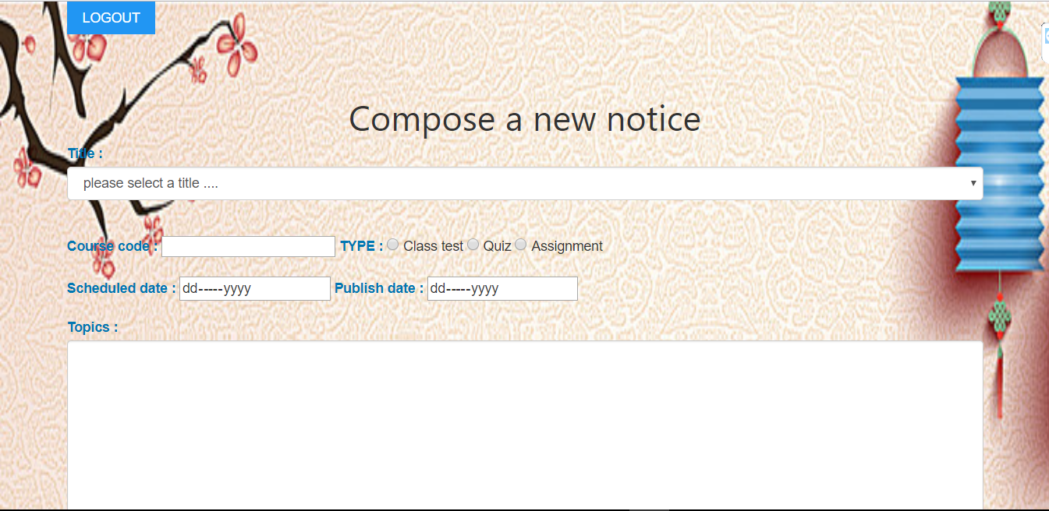Screenshot 4.1.1: Compose a new notice

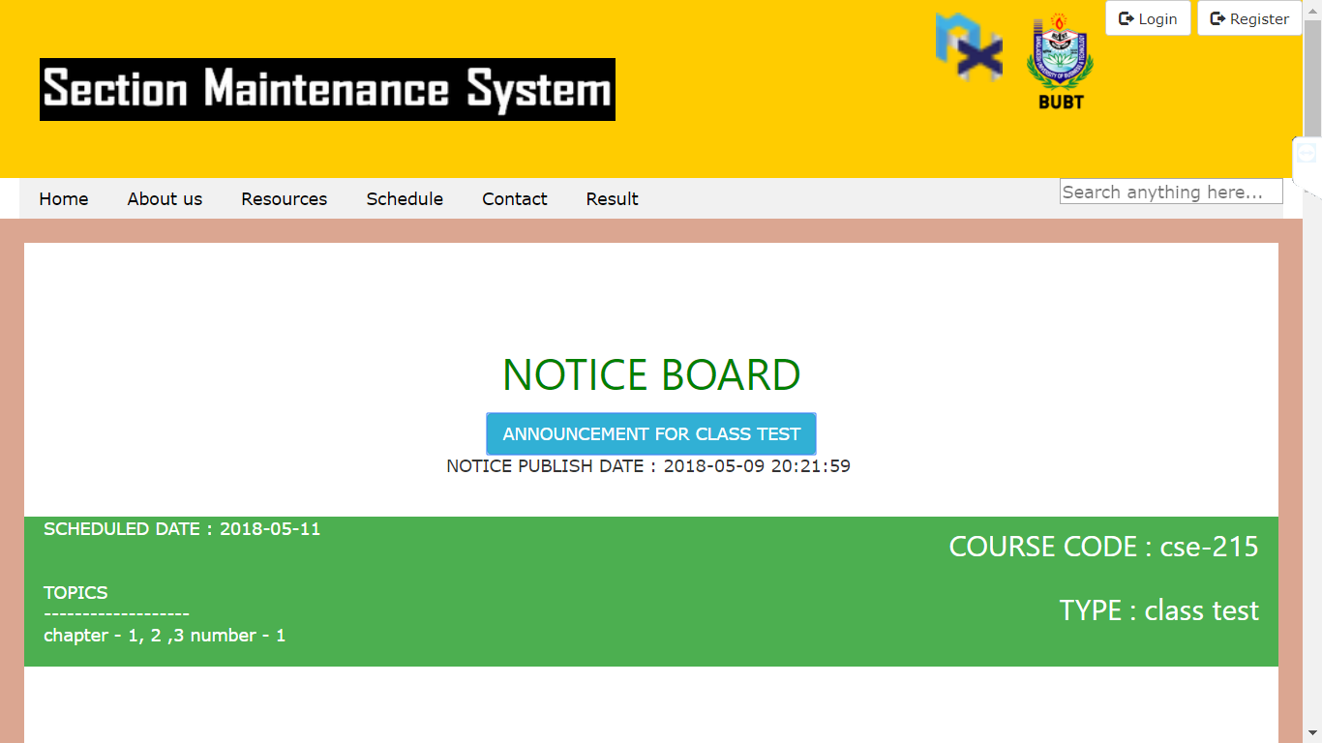

Screenshot 4.1.2: Home Page/Notice Board

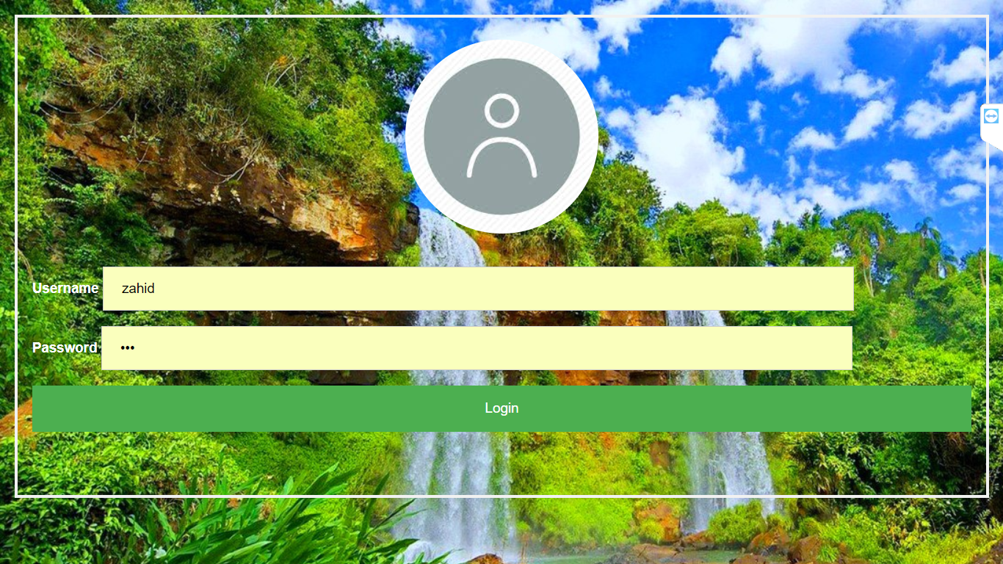

Screenshot 4.1.3: Login Menu

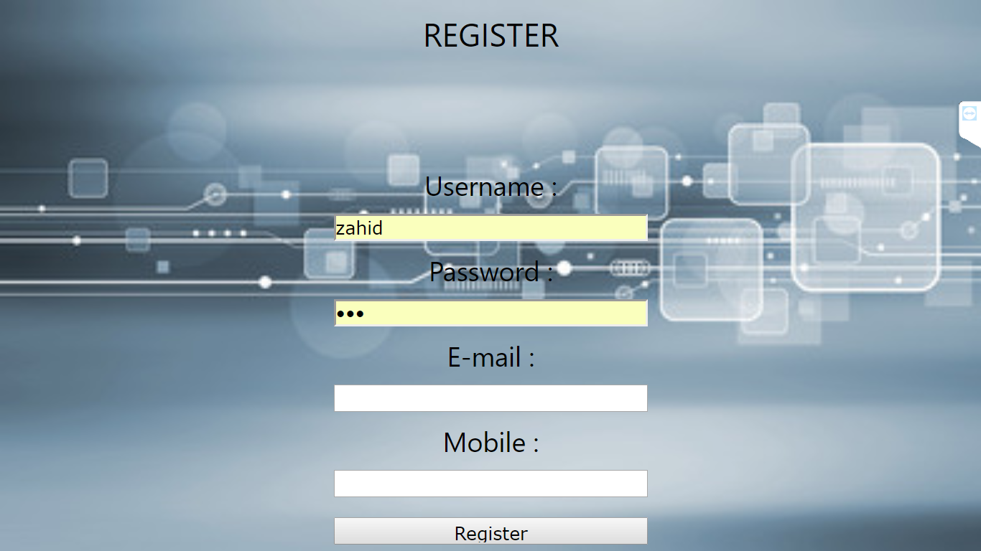

Screenshot 4.1.4: Admin Registration

CHAPTER 05
TECHNOLOGY AND LITERATURE REVIEW

- Hardware Requirements

- Processors – Intel® core i5
- Ram – 4 GB
- Hard Disk – 1 TB
- Mouse – Standard Mouse
- Keyboard – Logitech Keyboard
- Processor Speed – 2.2GHZ

- Software Requirements

- Operating System – Microsoft Windows 10 Pro.
- Basic Editing – Microsoft Word 2007
- Basic Develop – Notepad++, Xampp.

- Required Languages

- Coding language – PHP, HTML, CSS, SQL

CHAPTER 06
CONCLUSION
The section of university can handle full-scale computer and computer related resource. The Section Management System deals with all the activities done by this web such as class schedule, examinations schedule, assignment submission information, contacts with course teacher etc all these process are handled by section management system.

6.2 FUTURE ENHANCEMENT
We think this project would help students so much and we also hope that we can improve this web in future.

- In the Future Student can also be able to upload or download notes.
- We will see the entire system more interactive and also be able to give statistics data.
- We can run the entire system in any operating system and also we have an android/IOS application of this entire system.

6.1 LIMITATION OF THE SYSTEM
Although we have tried to make a successful project but there are some limitations.

- Due to security requirements Local user cannot use all utilities and modify system settings
- Not for mobile user

CHAPTER 07
DIAGRAMS

  - UX DIAGRAM
- 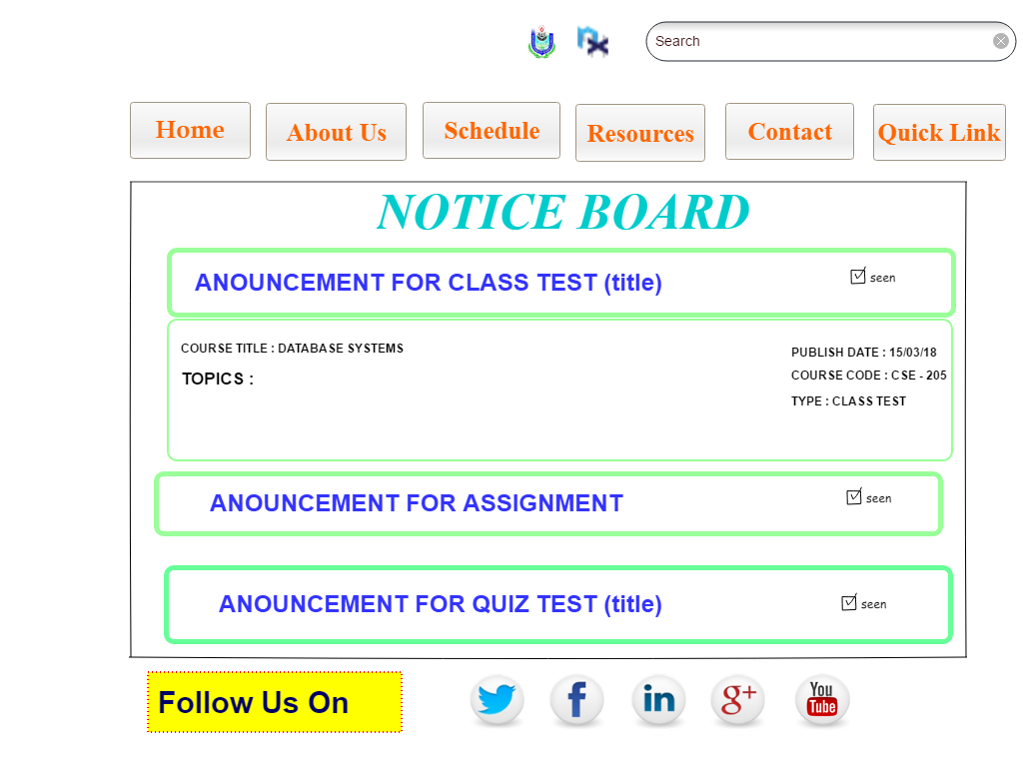
- Figure 7.1: UX Diagram

  - DFD
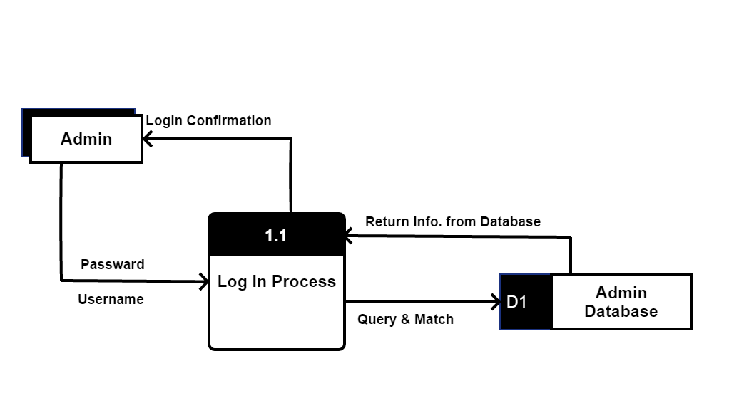
Figure 7.2.1: Log-In Process DFD
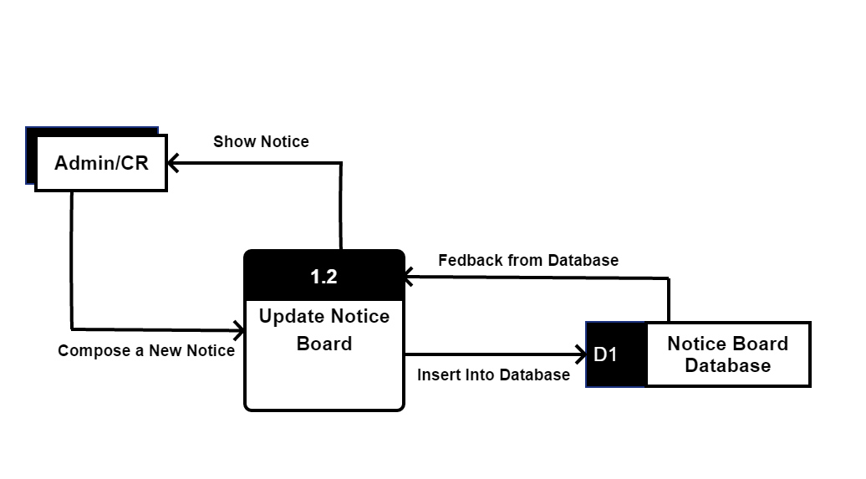Figure 7.2.2: Update Notice Board

- 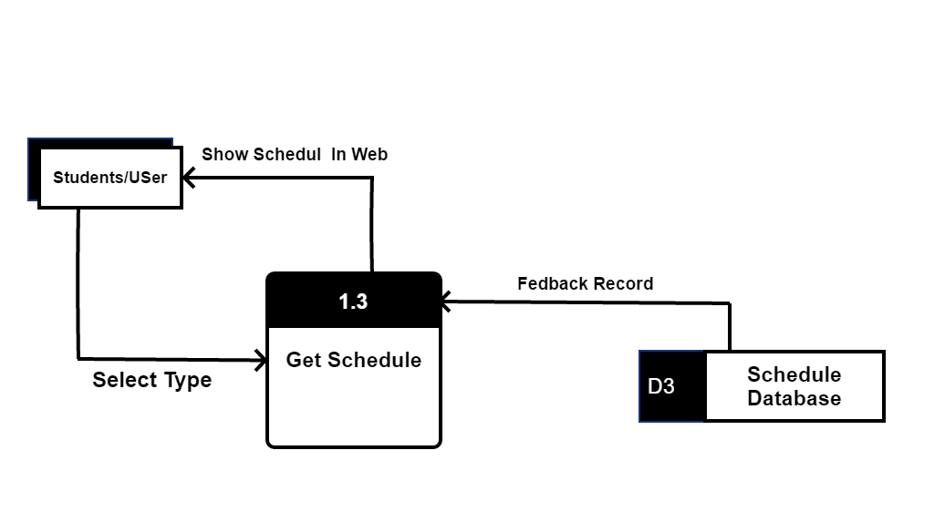Figure 7.2.3: Get Schedule DFD
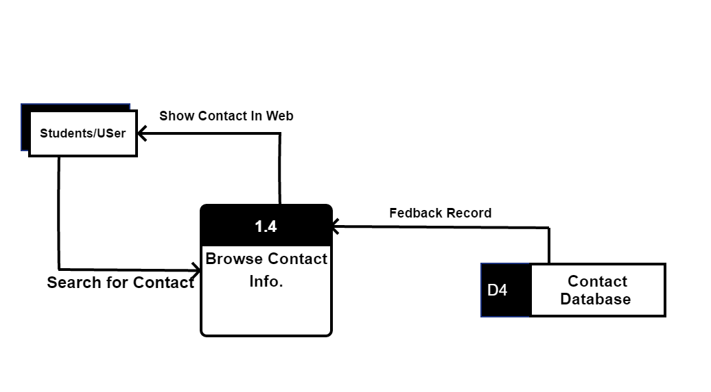Figure 7.2.4: Browse Contact Info. DFD

  - USE CASE DIAGRAM

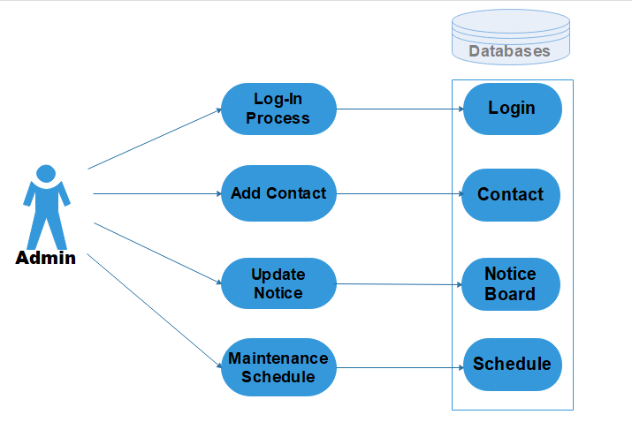

Figure 7.3.1: Admin Use Case
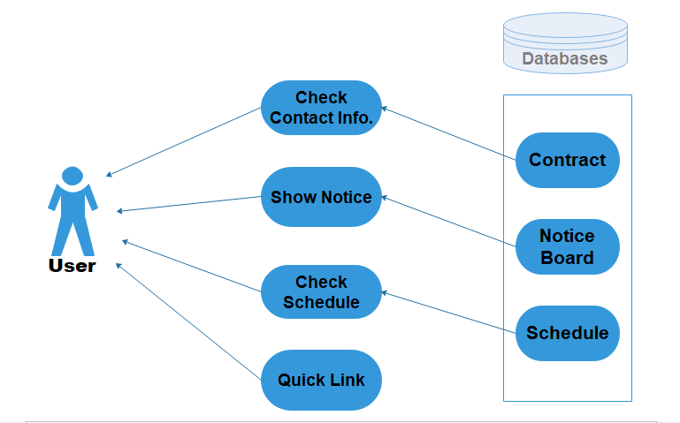
Figure 7.3.2: User Use Case

  - E-R DIAGRAM
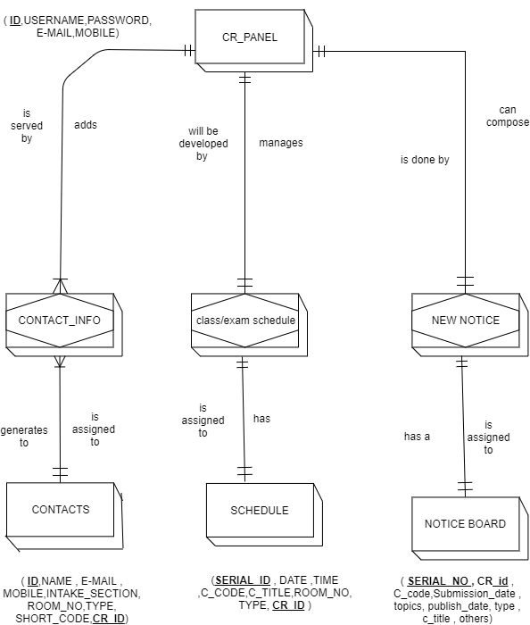
Figure 6.4.: E-R Diagram

